PHYTHON

**What is Python:**

* General purpose, High level , Interpreter programming language.
* Guido Van russom in 1991
* Dynamic type
* Block of code defined by Indentation.
* Dubugging : *python -m pdb python-script.py*
* Code -> Compiled -> byte code -> interpreted by PVM(python virtual machine)

**Pass by value / pass by reference:**

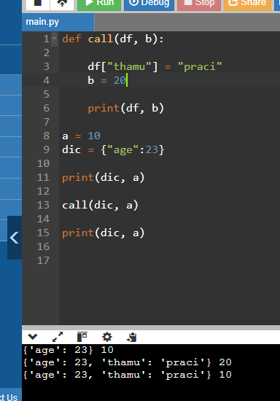

* Function receive reference to same object
* Mutable : list, dict can modified with in the function
* Immutable : int, str can not modified with in the function

**List, Tuple, Set, Dictionary, String:**

Mutable : The value can be changeable over runtime.

Immutable : The value can not be changed over runtime.

String : str() : It is Immutable ordered collection of character.

**List :** append, Insert, extend, pop, remove, reverse, sort, count, index, var[ind] = “val”,

**Set :** add, pop, intersection, union, symmetric_difference, difference, intersection_update, union_update

**Dict :** update, var[key] = “val” , pop, get, items, values, keys,

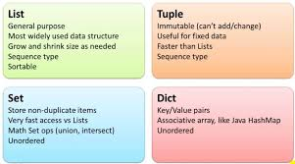

**List, set, dict comprehension:**

* Ease to Construct or create of <l, s, d> from iterable.
* List : [ i **2 for i in range(1, 4) ] // [1, 4, 9, 16]
* Set : { i **2 for i in range(1, 4) } // {1, 4, 9, 16}
* Dict : {I : i **2 for i in range(1, 4) } // {1: 1, 2: 4, 3: 9, 4: 16}

**What is function:**

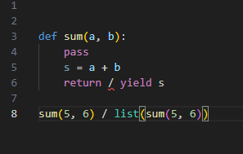

* Block of code, code reusability.
* Return act like break statement for func
* Pass is a keywork for creating empty function.
* function take functions as an argument. (Higher order Function)
* **\*arg** : passed parameter values as an Tuple collection.
* **\*\*kwargs :** passed parameter values as an dictionary
* Yielding the value is called Generator.

**Lambda Function:**

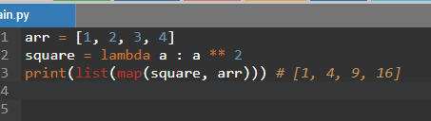

* One line anonymous function with only one expresstion.
* Syn : lambda args : expression
* It is useful when working with map, filter functions.

**Difference between /, //, %:**

* / : float result : 5/2 = 2.5
* // : Numerator result : 5/2 = 2
* % : denominator result : 5/2 = 1

**Exception Handling:**

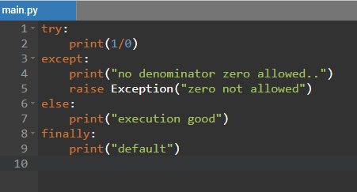

* Allow program to run even if error occur.
* Try .. except .. else .. finally
* For user defined error use : raise Exception (“error”)

**For loop, While loop difference:**

* **For :** loop through inerrable until the last value []
* **While :** Loop until the condition failed
* **Break :** Used to break the loop
* **Continue:** Used to skip the below move to next iteration.

**Variables:**

* Temporary memory location for store the value.
* Var = 10 (or) var:int = 10
* Types: Global, Local, Module level, Outer Most.

**Doc String:**

* It’s an documentation written write after Function, Class creation with triple quotes.
* It can be accessed using __doc__ function.

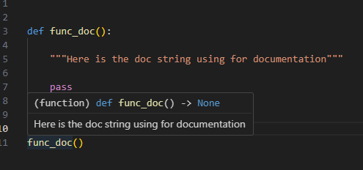

**What algorithm Function sort() and sorted() is using ?**

* Tim sorting algorithm. Stable sort. Worst case O(N log N).
* It’s a hybrid sorting algorithm derived from merge sort and insertion sort.
* Use numpy sort for difference algorithms => **np.sort(kind = “algo”)**

**Decorator:**

* Modify the functionality of the existing function without interrupting it.

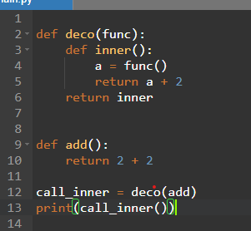

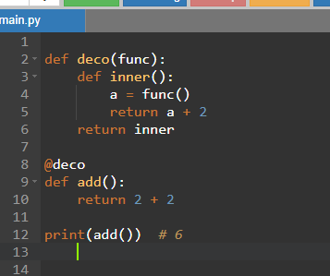

**Class in Python:**

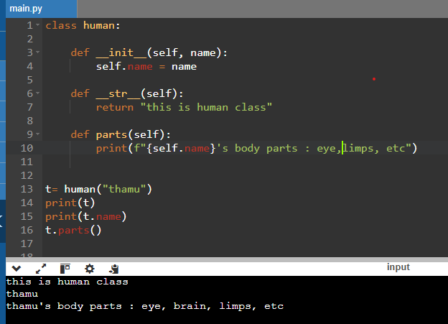

* Class is an OOPs concept. In python almost everything is objects.
* Class is object constructor or blueprint for creating the object.
* Object is instance of a class.
* Class is a keyword.
* __init__ : function is constructor. Called when object created.
* __str__ : function return value for class generator.
* Self : object reference. Used to uniquely identify the objects.
* t : is the object for human class, we can create many objects.
* Types : Inheritance, Polymorphism, Encapsulation, Abstraction.

**Inheritance class:**

* Child class can access all the methods and attributes of the parent class.
* It is used for version control.
* Types : single , Multiple inheritance

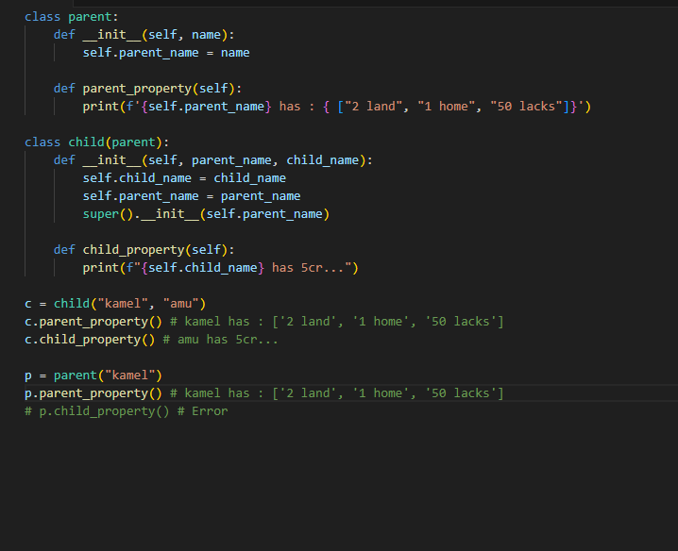

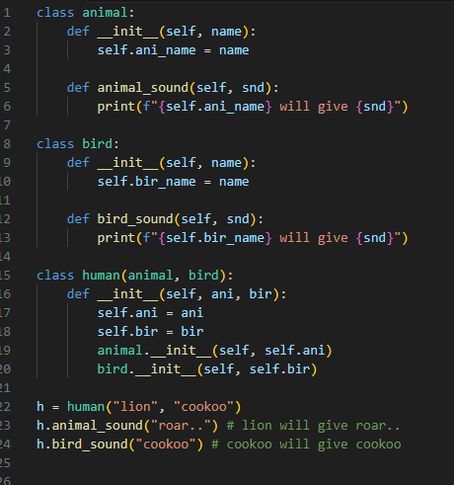

**Polymorphism class:**

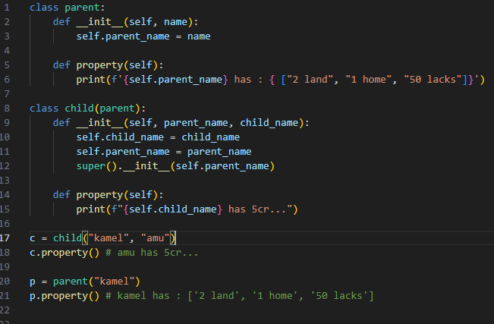

* Function, attribute with same name can

executed on different object or class.

* Ex: len(“thamu), len([1, 2,3]) etc.
* Here. Property function is same name

But in the different class.

* If the class is inherited then the parent func

Overwritten by child class.

* If func not in child, it will call parent func

**Encapsulation class:**

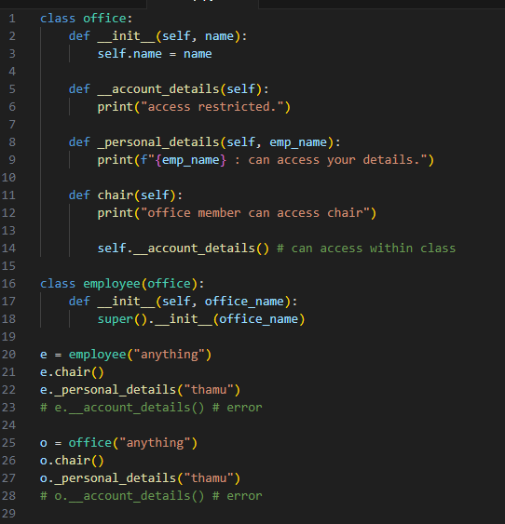

* Bundling data and methods within a class and

Restrict direct access to the internal state from

Outside.

* Access Modifiers: Public, private, protected.
* Public : can access all over the package.
* Private (__na): can access within the block.
* Protected(_na): access within block and it’s

Inherited class.

**Abstraction Class:**

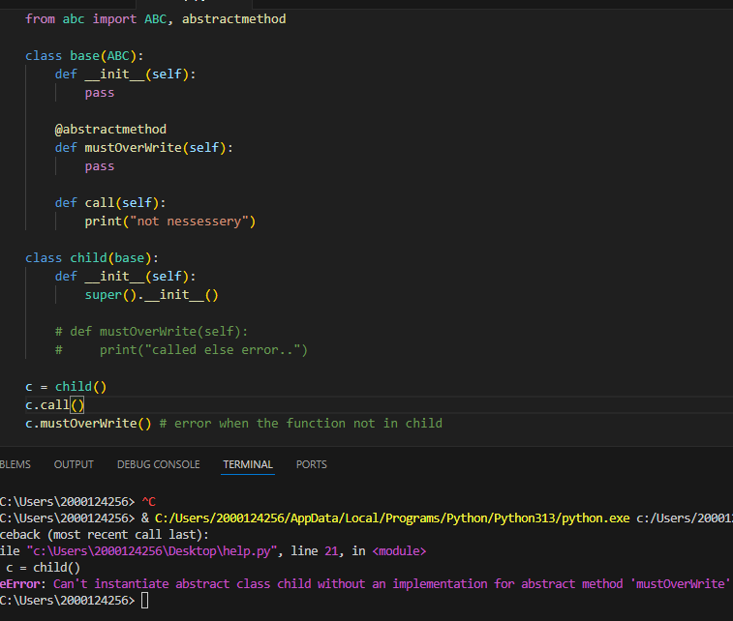

* Hiding the functionality and essential information

From user.

* They act as placeholder method, It must be overwritten

By its subclass..

* It can achieve by using **abc** package in python.
* Base is inherited from ABC class and the method

mustOverWrite having decorator @abstractmethod.

* This mustOverWrite should be overwritten by its

Child class.

* @abstractmethod if we not decorate the function no

Need to overwrite the function in the child.

**Name Mangling:**

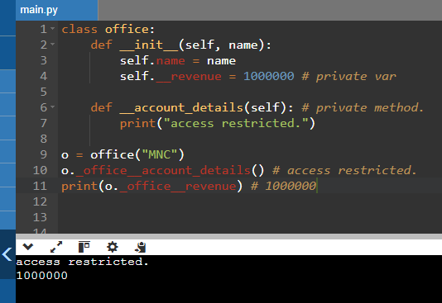

* Private method also can be accessible outside its class

Using Name mangling technique.

* Syntax: **obj._className__identifier**

**Python Important Functions:**

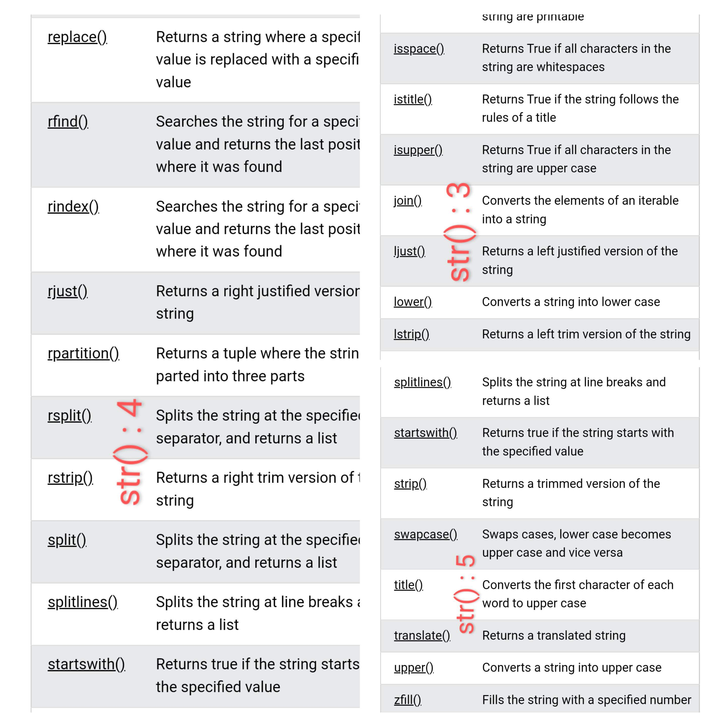

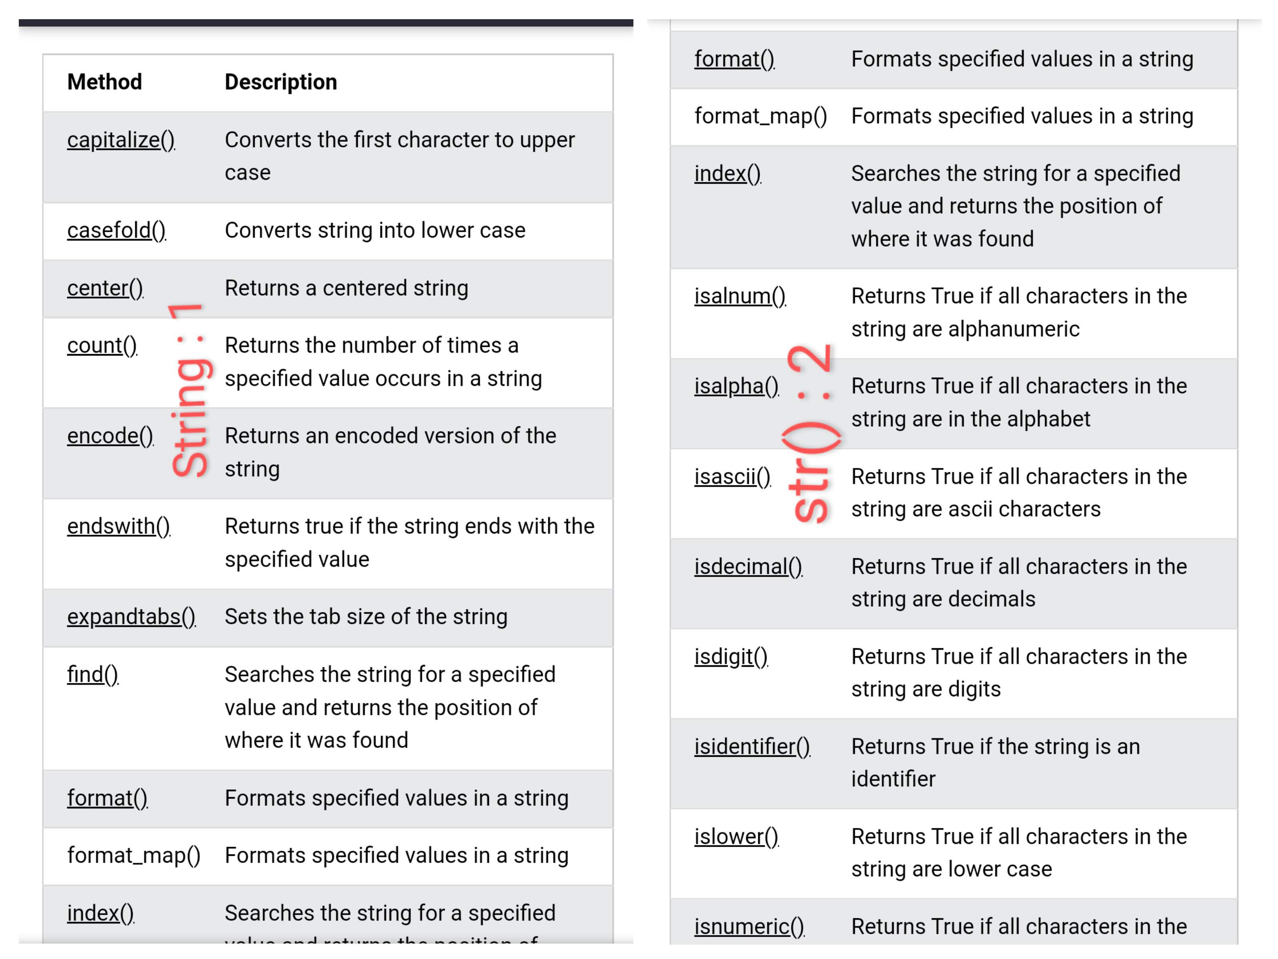

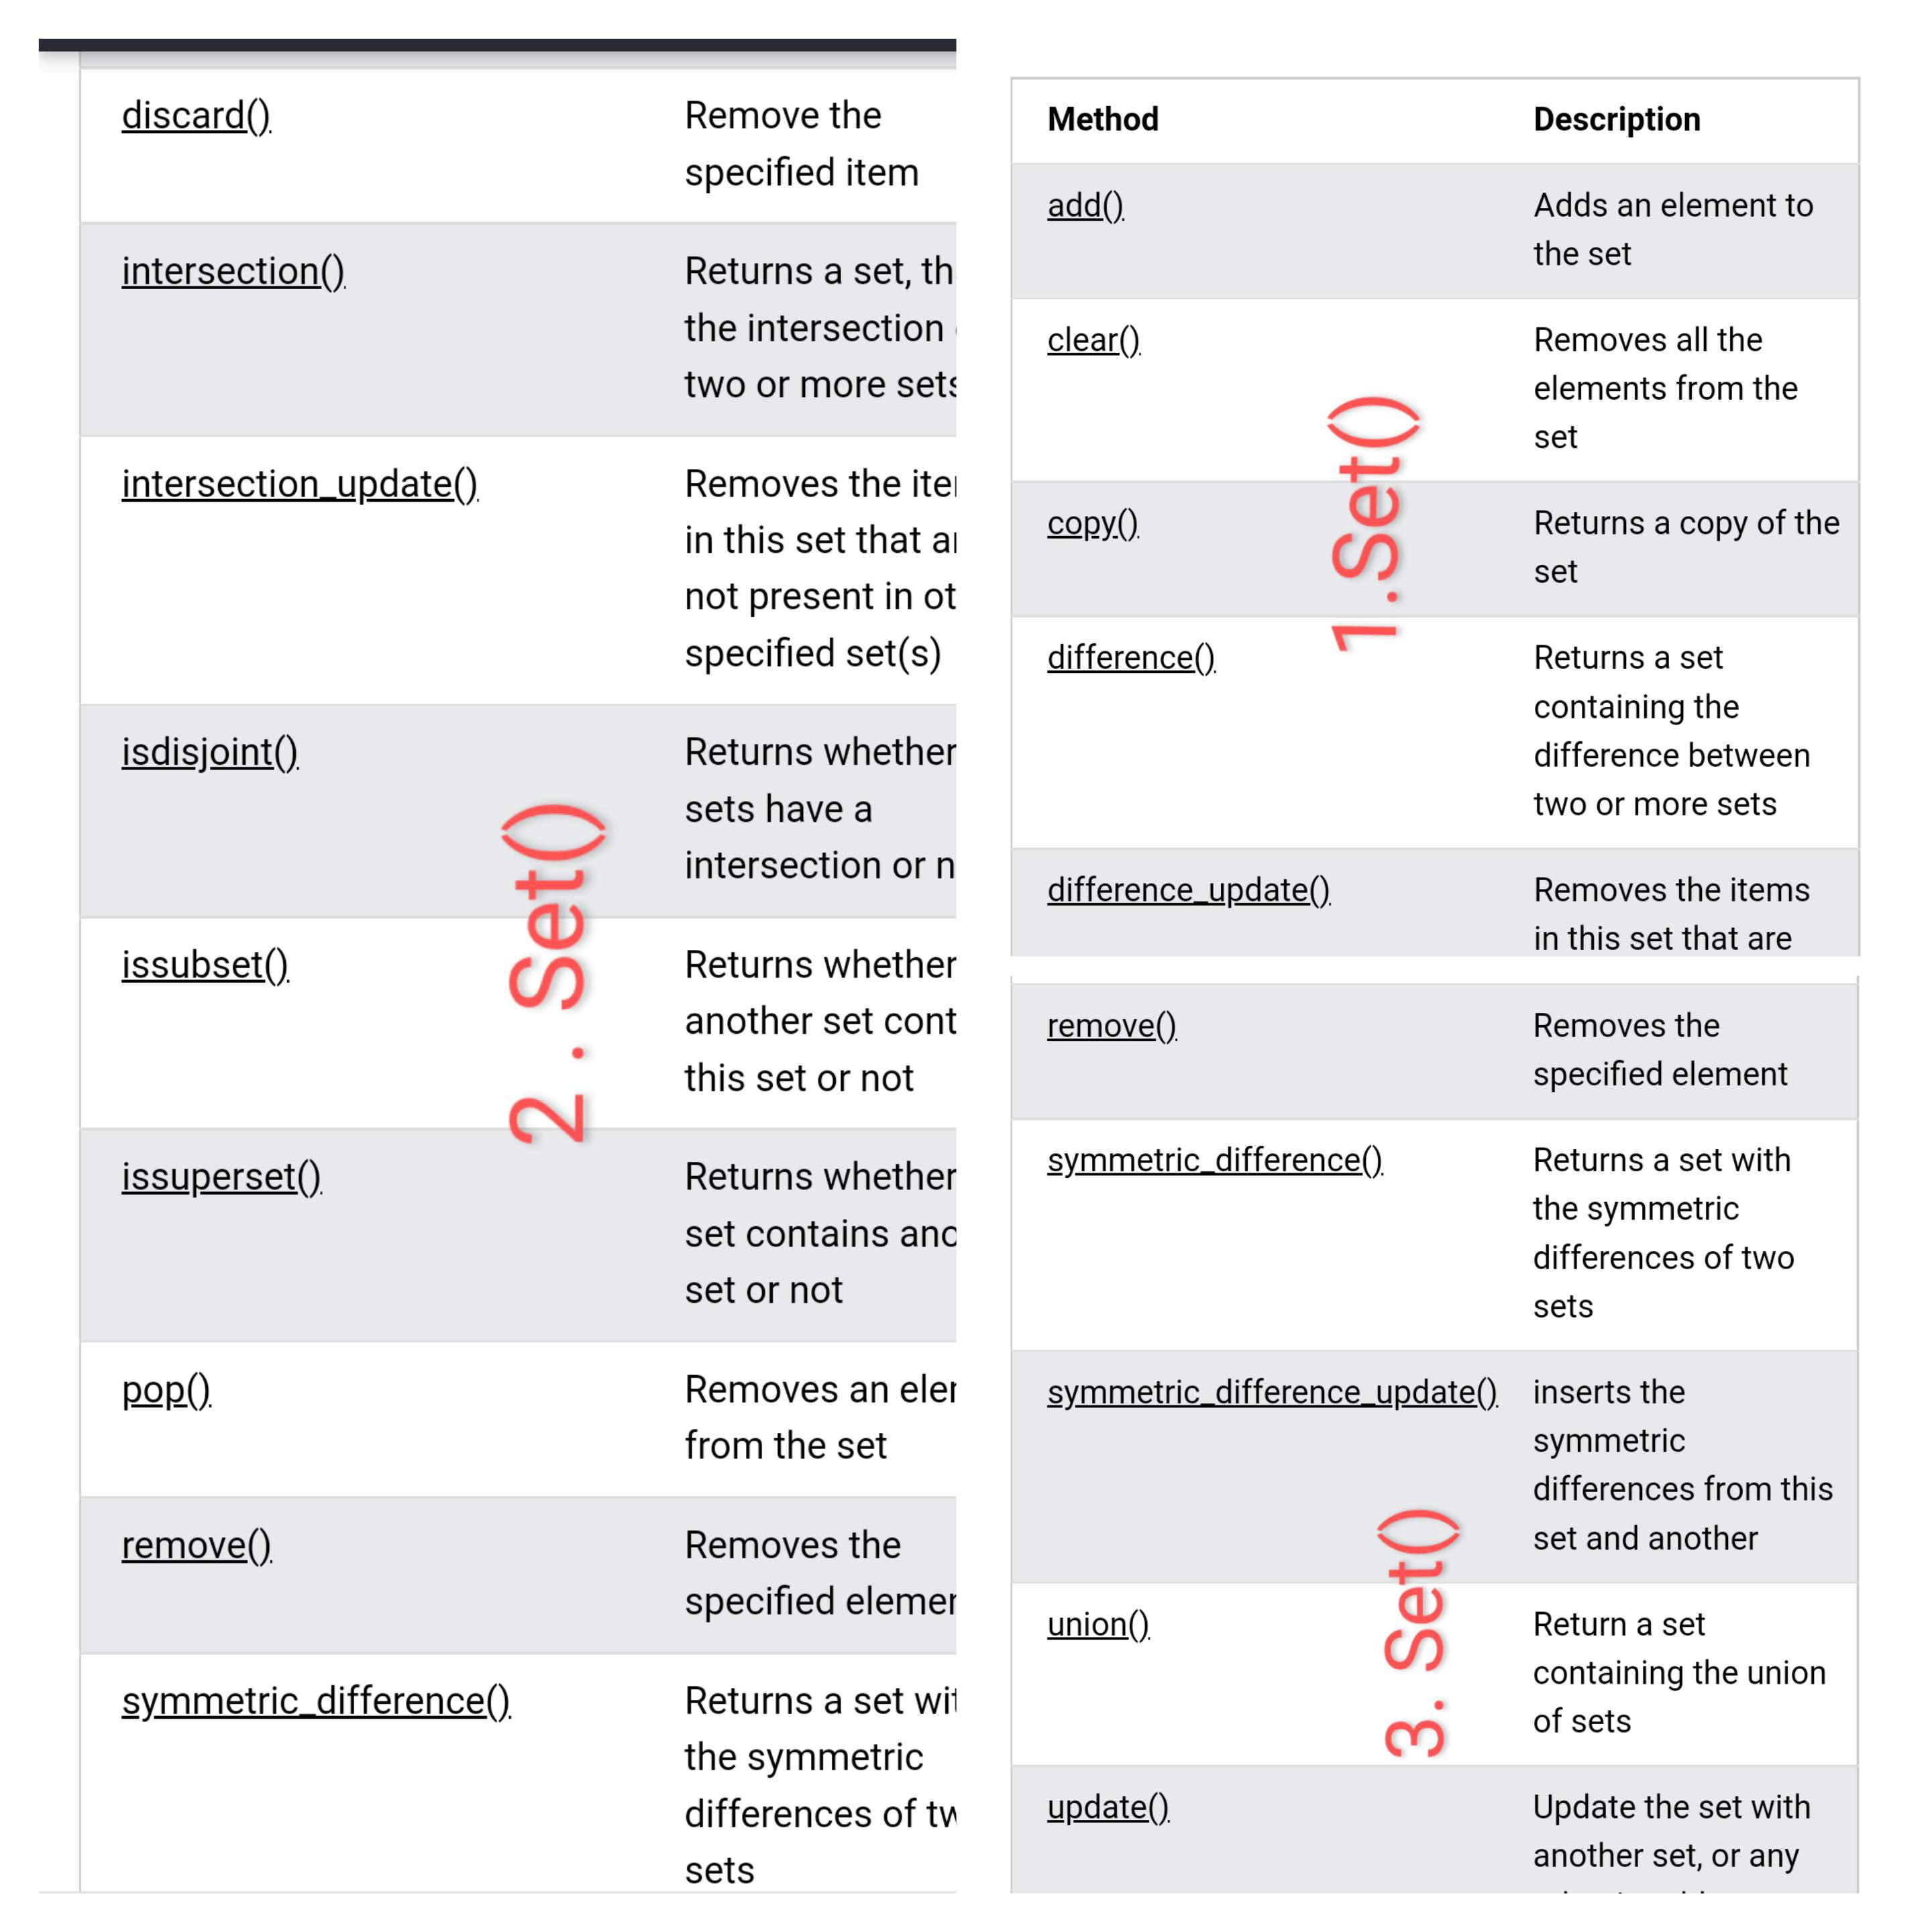

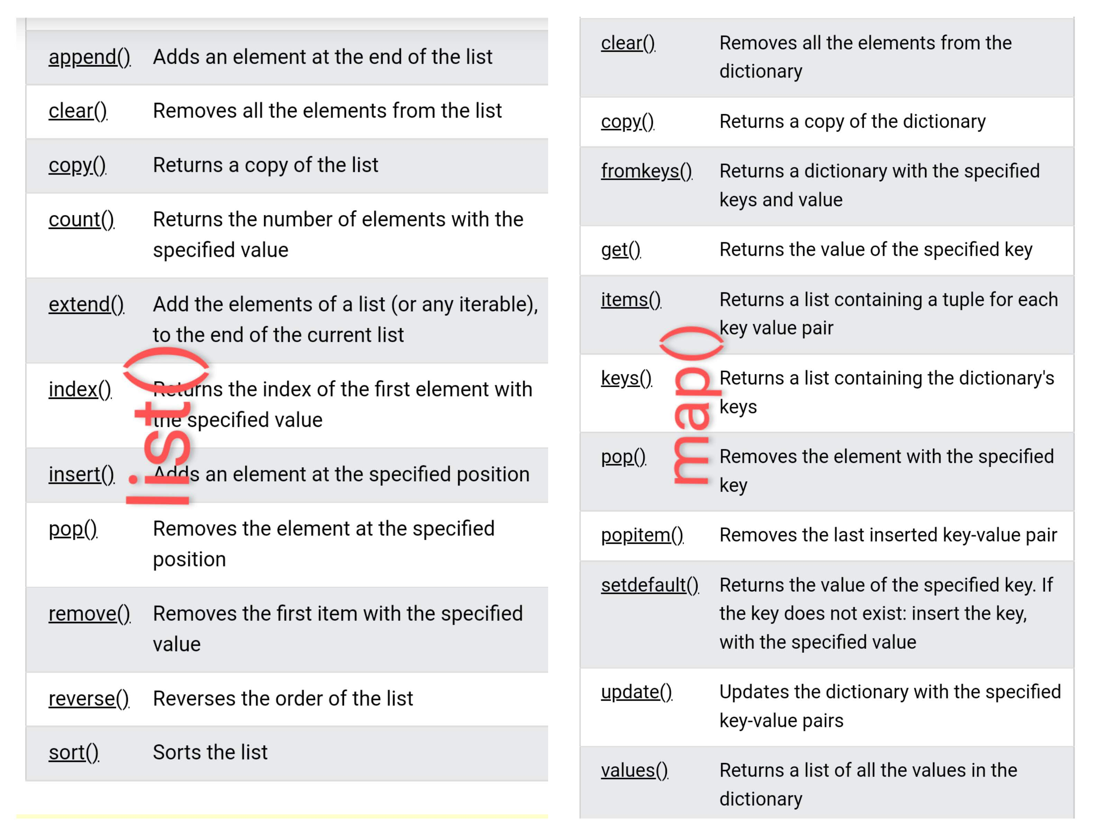

**Numpy: (Numerical Python)**

**Define Numpy:**

* It is a python library that used to work with Array.
* It faster than List. Because it store value continuous location in the memory.
* Pip install numpy
* Import numpy as np.
* All the inbuild function will be under numpy class. Ex : np.array(),
* In Ndarray,.. attribute [ axis = 0 : Row, axis = 1 column ]
* Data types: I (int64), b (bool), f (float), m (timedelta), M (datetime), O (object), S (string).

**CRUD Operation:**

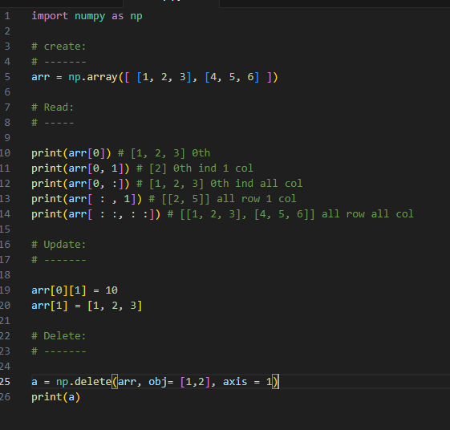

* **Create :** arr = np.array(arr = [], dtype = i , ndmin = 3)
* **Read :** arr[ : : , : : ]
* **Update :** arr[ind] = new_val
* **Delete :** np.delete(arr, int/list, axis)

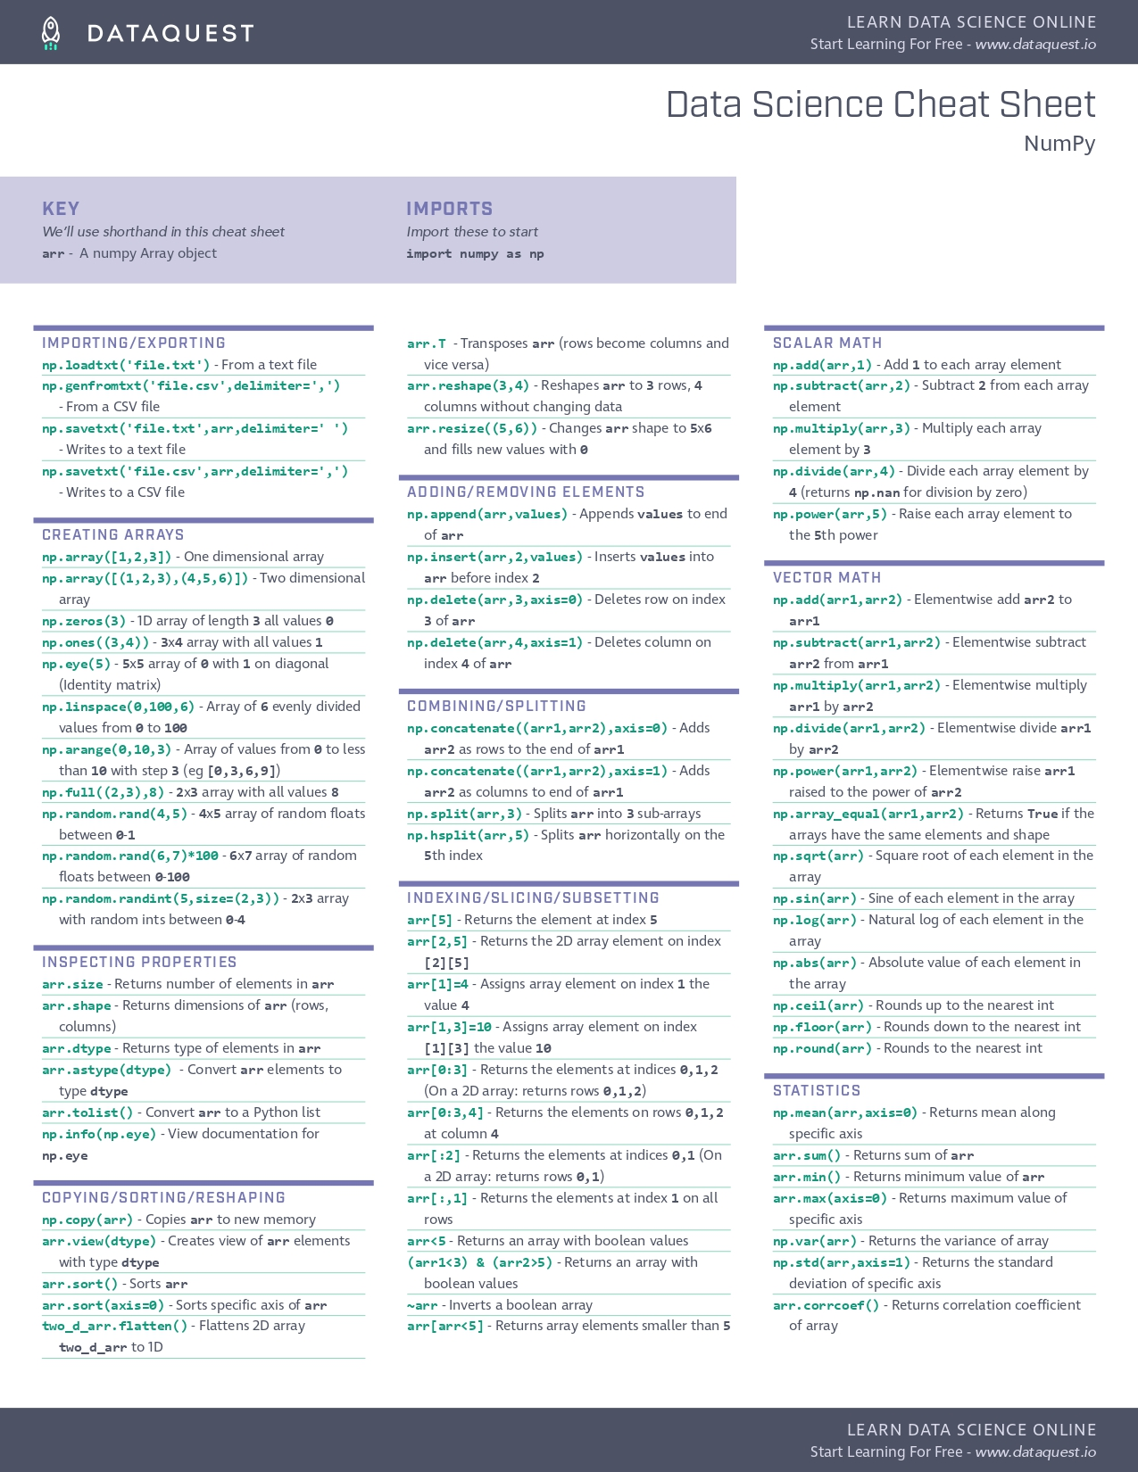

**Pandas:**

**Define Pandas:**

* Pandas is a python library. Used to analyse data. The data will be like rows and columns
* Pandas will be closely used to work with files like csv, excel, json, xml, parquet etc.

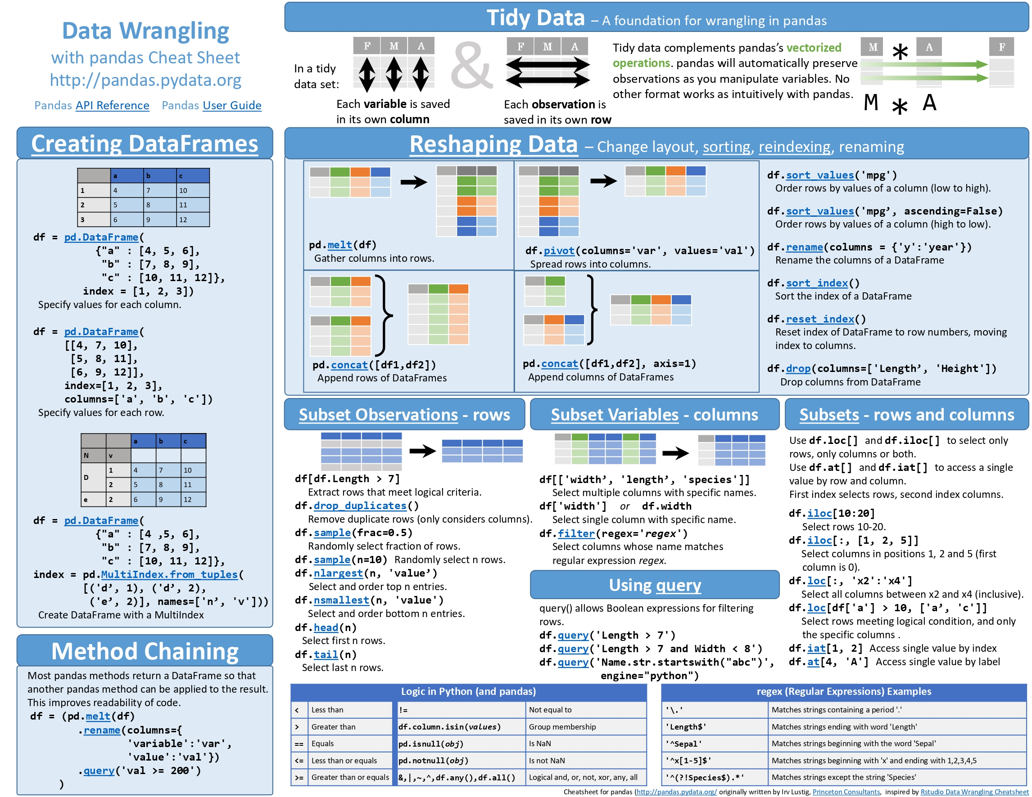

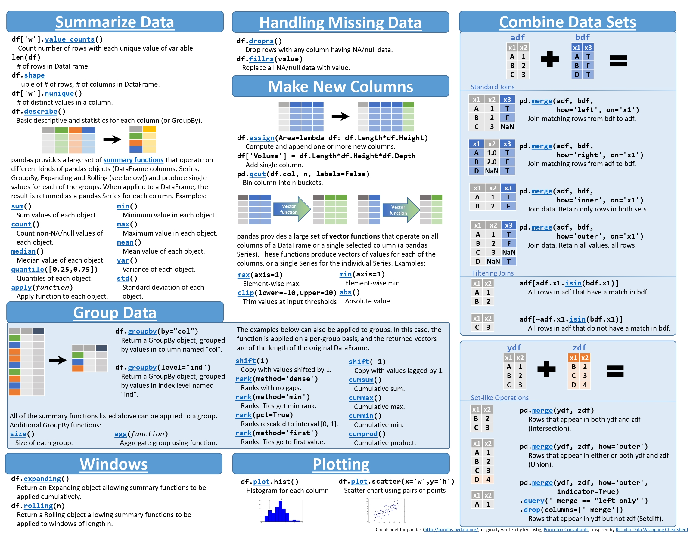

**Important Modules:**

Link : https://www.geeksforgeeks.org/python-libraries-to-know/

|  |  |
| --- | --- |
| itertools | Permutations, combinations |
| smtplib | Send email using python. |
| Matplotlib.pyplot | Working with Graph |
| Mysql.connector.connect | Working with mysql, (similar for mssql, sqlite) |
| request | Work with network |
| Opencv, cv2 | Work with computer vision, image processing |
| pygui | Work with Graphical user interface. |

**SQL**

**What is sql:**

* Structure Query Language for storing, manipulating and retrieving data in Database.

**Sql Commands:**

* **DDL** : Data Definition Language
* Create – database, table, view, index, trigger
* Drop - database, table, view, index, trigger
* Truncate - table
* Alter – table definition and column
* **DML :** Data Manipulation Language
* Insert
* Update
* Delete
* **DQL:** Data Query language
* Select
* **TCL:** Transaction Control Language

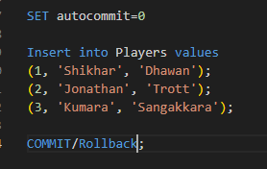

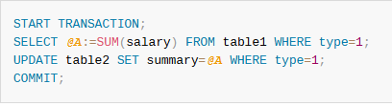

* Rollback
* Commit
* Save point
* **DCL:** Data Control Language
* Grand
* Revoke
* **Grand <**privilege_name> **on <**object_name> **to <**user>
* Privileges : sql commands : select, insert, update etc..
* Object Name : table name

**Sub – Query:**

* Query within another query is called sub-query
* Types:
* Corelated : inner and outer query are interdependent.
* Scalar : Give single value as result.
* Single row : Give single row as result.
* Nested : Having multiple sub-queries.

**Constraints:**

* Primary key – Not null + unique
* Foreign key -
* Unique – no duplicate
* Not Null – No null allowed
* Check – condition should be true then insert
* Default – if user value no then default value filled
* Auto_increment – auto generated incremental value

**Query Syntax:**

|  |  |
| --- | --- |
| Commands | Query |
| Create database | Create database <db_name>; |
| Create table | Create or replace table <tbl_name> ( col_name dtype constraints )  Partition by col1, col2 etc.  Cluster by col1, col2 .. col4  Constraints ( col )  Create or replace table <tbl_name>  Partition by col1, col2 etc.  Cluster by col1, col2 .. col4  As  <select query> |
| Truncate | It cannot be rollback. It is auto commit process.  Truncate table <table_name>; |
| alter | Alter table <tbl_name>  Rename to <new tbl name>  Alter table <tbl_name>  Add column <col_name> <dtype> <constraints>.  alter table <tbl_name>  Drop column <col_name>  Alter table <tbl name>  Rename column <old col name> to <new col name>  Alter table <tbl name>  Modify <col name> <constraints>  Alter table <tbl_name>  Add constraint <cons_name> <column_name> <constraints> |
|  |  |
| Create index | Create index <ind_name> on <tbl_name>( col list ) |
| Create view | Create view <vw_name>  as  (select Query) |
| Create trigger | Create trigger <tri_name>  Before / after  Insert / update / delete  On <tbl_name>  <trigger body> |
| insert | Insert into <tbl_name> ( col1, col2, etc )  Values ( val1, val2 etc )  Insert into <tbl_name>  <select query>  Select <cols> into <tbl / var> from <tbl_name> |
| update | Update <tbl_name> set col1 = val1, col2 = val2  Where <condition> -- without condition all record will update.  Update <tbl1_name> set col1 = val1, col2 = val2  From <tbl2 name>  Join <tb3 name> on <condition>  Where <condition> |
| delete | Delete from <tbl_name>  Where <condition> -- without condition all record will update.  Delete <trg table>  from <tbl1 name>  Join <tb2 name> on <condition>  Where <condition> |
| Select | Select [distinct] <cols>  from <tbl name>  [ inner / left / right / cross] join <tbl_name 2>  On <condition>  where <condition> (in, any, all, exists, between, like)  group by <cols> having <condition>  order by col1 asc / desc, col2 asc / desc  limit n |
| merge | Merge into <src tbl> as s  Using <trg tbl> as t On s.col = t.col  When [ not ] matching  update set col = val  insert (cols) values (vals)  delete |

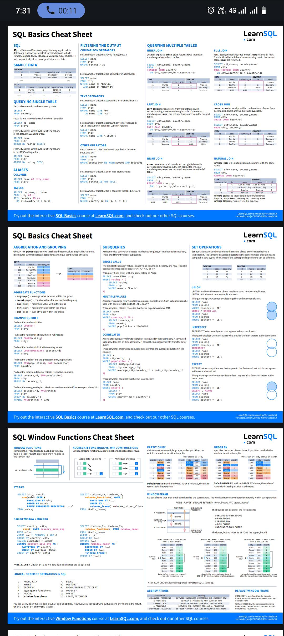

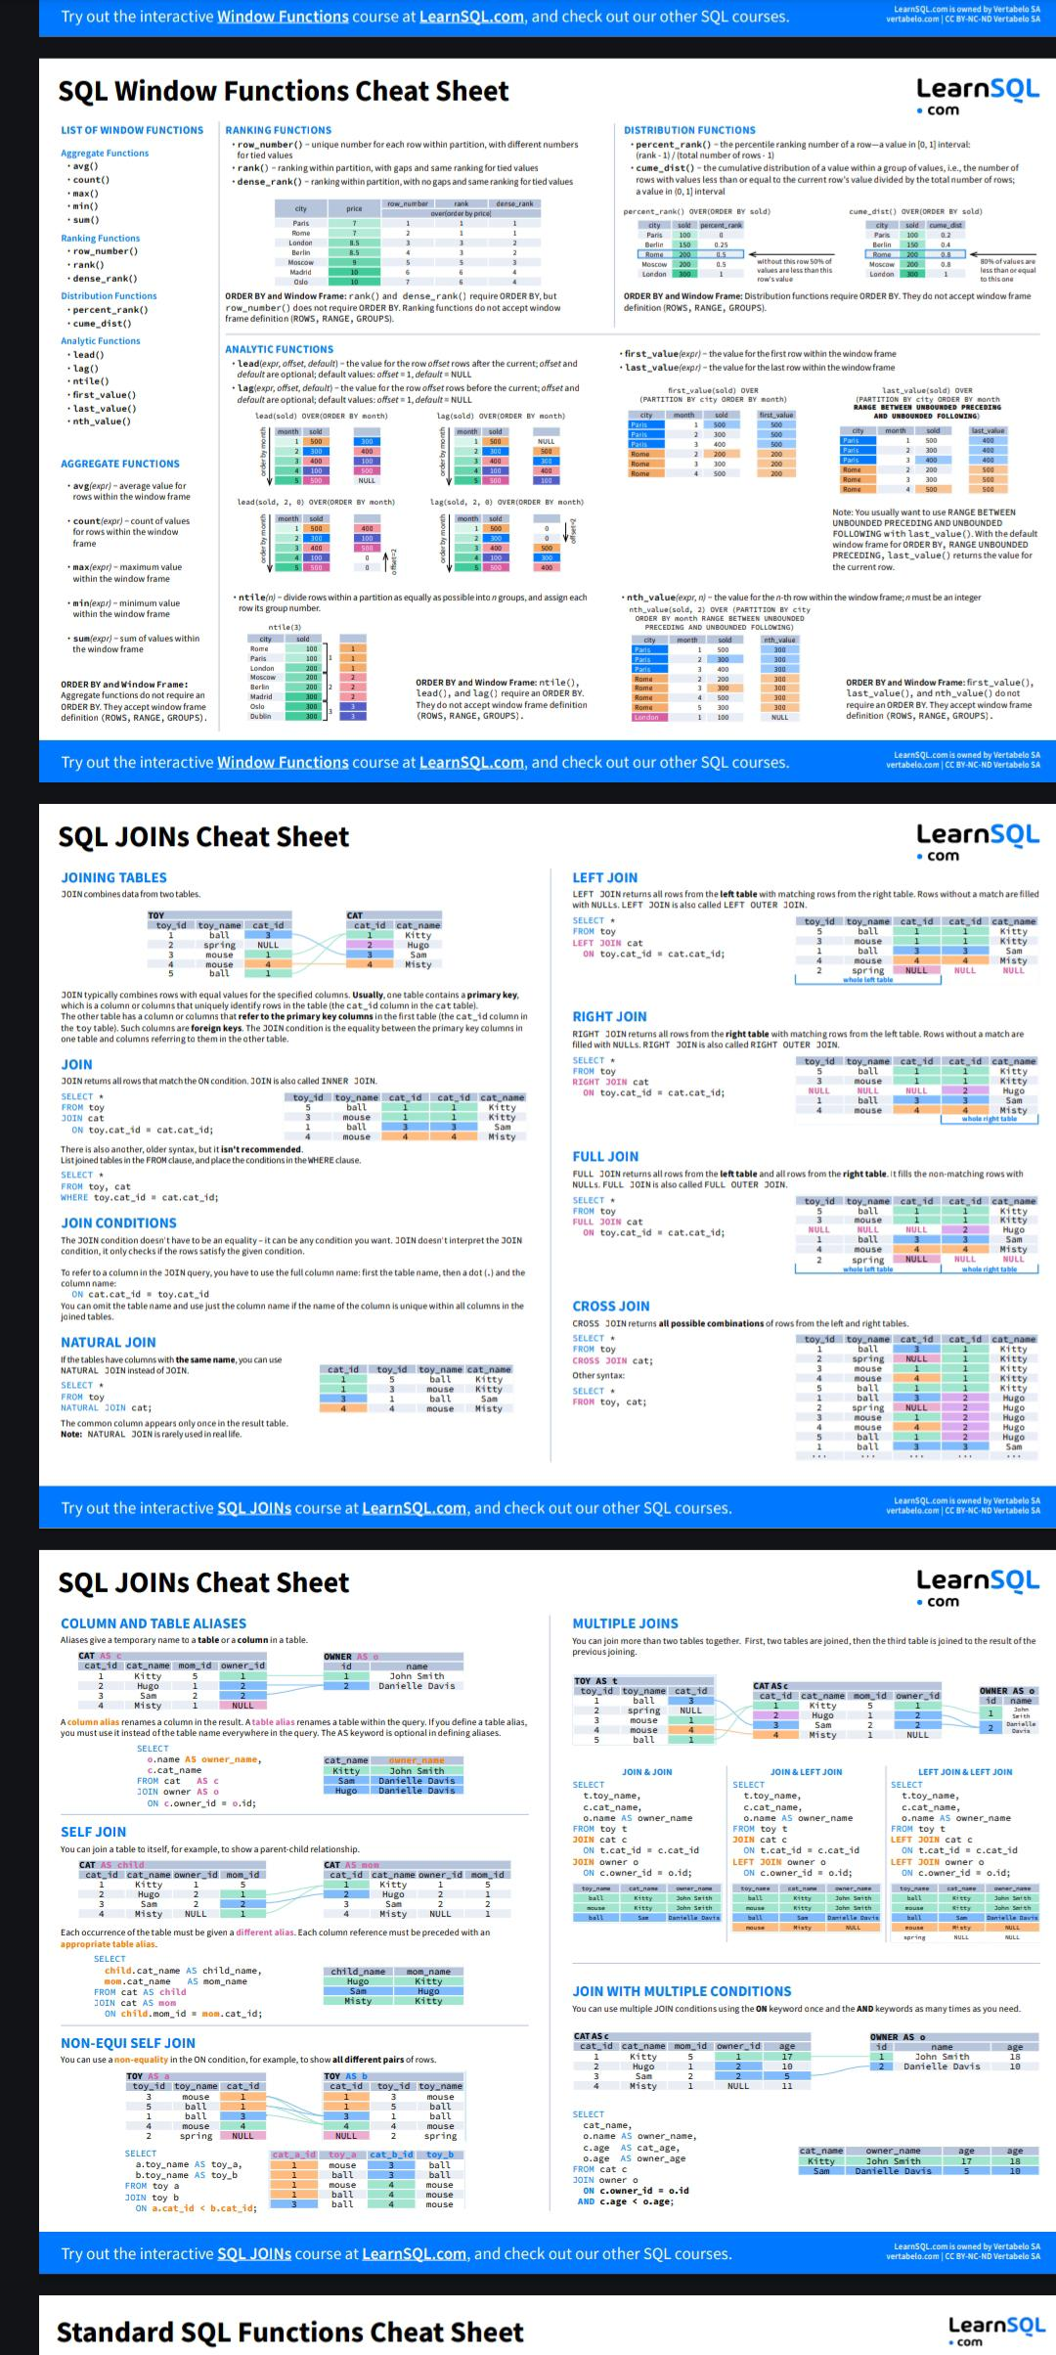

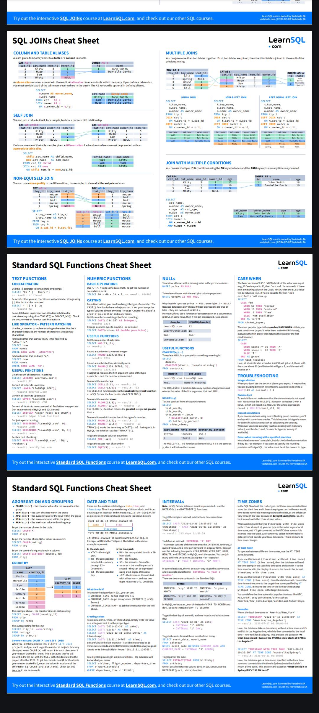

**QN:**

|  |  |
| --- | --- |
| **Nth highest salary** | **::** with tb1 as (      select salary, dense_rank() over(salary desc) as rnk      from employee as e  )  select distinct salary from tb1  where rnk = n  **::** with tb1 as (      select distinct salary from employee as e      order by salary desc      limit 1 offset n  )  select * from salary |
| **Department wise highest**  **salary** | **::** with tb1 as(      SELECT CountryCode, Population,      dense_rank() over(partition by CountryCode order by Population desc) as rnk      FROM world.city  )  select * from tb1 where rnk = 1 |
| **Duplicate row** | **::** with tb1 as(      SELECT CountryCode, Name,      count(CountryCode) over(partition by CountryCode) as cnt      FROM world.city  )  select distinct CountryCode, cnt from tb1  where cnt > 1 |
| **Delete duplicate** | **::** delete t1 from learn.student_details as t1  join learn.student_details as t2  on t1.teachers_id = t2.teachers_id  where t1.student_id > t2.student_id; |
|  |  |
|  |  |